**Deep Learning Techniques for Breast Cancer Risk Prediction**

**CONTENTS**

|  |  |  |
| --- | --- | --- |
| **S No** | **TOPIC** | **PAGE** **No** |
| **1** | **ABSTRACT** | **2** |
| **2** | **INTRODUCTION** | **3** |
| **3** | **LITERATURE SURVEY** | **4** |
| **4** | **THEORITICAL ANALYSIS** | **5-6** |
| **5** | **EXPERIMENTAL INVESTIGATIONS** | **7-8** |
| **6** | **FLOWCHART** | **9** |
| **7** | **RESULT** | **10** |
| **8** | **ADVANTAGES AND DISADVANTAGES** | **11** |
| **9** | **APPLICATIONS** | **11** |
| **10** | **CONCLUSION** | **12** |
| **11** | **FUTURE SCOPE** | **13** |
| **12** | **BIBILOGRAPHY** | **14-15** |

**1.ABSTRACT**

Breast cancer is one of the most common cancer diseases in worldwide; breast cancer happens in both men and women, generally more common in women. Many kinds of research are done so

far to diagnosis and the case. This paper is a review of the researches for diagnosing the breast cancer and detect it in an early stage by classifying mammography of images , in this review explore the importance of deep learning and experimentally determine the best fine-tuning strategy to adopt when training a CNN model, Computer-aided Diagnosis system based on deep Convolutional Neural Networks (CNN) that goals to help the radiologist classify mammography mass lesions. Deep learning usually requires large datasets to train networks of a certain depth from beginning, using various number of dataset model, for example achieved to 97.35% accuracy and 0.98 AUC on the DDSM database, 95.50% accuracy and 0.97 AUC on the INbreast database and 96.67% accuracy and 0.96 AUC on the BCDR database. Additionally, after pre- processing and normalizing all the extracted Regions of Interest (ROIs) from the full mammograms, also merged all the datasets to build one large set of images and used it to fine-tune our CNNs,finally obtained determine that the framework is performant and can truly be used to determine if the breast cancer are appear or not.

**2. INTRODUCTION**

* Breast cancer is one of the leading causes of death for women globally. According to the World Health Organization (WHO), the number of cancer cases expected in 2025 will be 19.3 million cases. In Egypt, cancer is an increasing problem and especially breast cancer.
* The prediction of breast cancer susceptibility – risk assessment prior to occurrence. (Diagnosis) 2. The prediction of breast cancer recurrence – likelihood of redeveloping (Prognosis) 3. The prediction of breast cancer survivability – life expectancy, survival, progression, tumor-drug sensitivity (Prognosis)
* Breast cancer is one of the main causes of cancer death worldwide. Computer-aided diagnosis systems showed the potential for improving diagnostic accuracy. But early detection and prevention can significantly reduce the chances of death. It is important to detect breast cancer as early as possible.
* The goal is to classify images into two classifications of malignant and benign. As early diagnostics significantly increases the chances of correct treatment and survival. In this application, we are helping the doctors and patients to classify the Type of Tumour for the specific image given with the help of Neural Networks.
* **2.2 Purpose:** What can I do to reduce my risk of breast cancer?Research shows that lifestyle changes can decrease the risk of breast cancer, even in women at high risk. To lower your risk:Limit alcohol.
* The more alcohol you drink, the greater your risk of developing breast cancer. The general recommendation — based on research on the effect of alcohol on breast cancer risk — is to limit yourself to no more than one drink a day, as even small amounts increase risk.Maintain a healthy weight.
* If your weight is healthy, work to maintain that weight. If you need to lose weight, ask your doctor about healthy strategies to accomplish this. Reduce the number of calories you eat each day and slowly increase the amount of exercise.Be physically active.
* Physical activity can help you maintain a healthy weight, which helps prevent breast cancer. Most healthy adults should aim for at least 150 minutes a week of moderate aerobic activity or

**3. LITERATURE SURVEY**

**3.1 Existing problem:** Automated defect detection in medical imaging using machine learning has become the emergent field in several medical diagnostic applications.In general, diagnosing a brain tumor usually begins with magnetic resonance imaging (MRI). Once MRI shows that there is a tumor in the brain, the most common way to determine the type of brain tumor is to look at the results from a sample of tissue after a biopsy or surgery. This is a normal way to detect the brain tumor

**3.2 Proposed solution:** Here we are going to detect the tumor using a human trained model we trained our model using nearly 500 images and we got an accuracy of nearly 99%. And the person can collect there MRI and then he upload the copy of an image in our webpage then from there he can get know he is having an tumor in his brain or not. And then from there he can proceed for the further surgery steps.

**4. THEORITICAL ANALYSIS**

**4.1 Block diagram:**

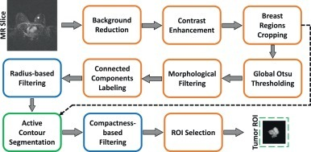

**4.2 Hardware / Software designing:**

**Software Requirements:**

Python 3 - We have used Python which is a statistical mathematical programming language like R instead of MATLAB due to the following reasons:

1. Python code is more compact and readable than MATLAB

2. The python data structure is superior to MATLAB

3. It is an open source and also provides more graphic packages and data sets Keras (with TensorFlow backend 2.3.0 version) - Keras is a neural network API consisting of TensorFlow, CNTk, Theano etc. Python packages like Numpy, Matplotlib, Pandas for mathematical computation and plotting graphs, SimpleITK for reading the images which were in .mha format and Mahotas for feature extraction of GLCM Kaggle was used to obtain the online dataset. GitHub and Stackoverflow was used for reference in case of programming syntax errors. OpenCV (Open Source Computer Vision) is a library of programming functions aimed at real time computer vision i.e. used for image processing and any operations relating to image like reading and writing images, modifying image quality, removing noise by using Gaussian Blur, performing binary thresholding on images, converting the original image consisting of pixel values into an array, changing the image from RGB to grayscale etc. It is free to use, simple to learn and supports C++, Java, C, Python. Its popular application lies in CamScanner or Instagram, GitHub or a web-based control repository. Google Colaboratory (open-source Jupyter Notebook interface with high GPU facility) - Google Colab /Colaboratory is a free Jupyter notebook environment that requires no setup and runs entirely on cloud. With Colab, one can write and execute code, save and share analyses, access powerful computing resources, all for free from browser.[Jupyter Notebook is a powerful way to iterate and write on your Python code for data analysis. Rather than writing and rewriting an entire code, one can write lines of code and run them at a time. It is built off of iPython which ©RCCIIT, DEPT. OF EE Page 20 is an interactive way of running Python code. It allows Jupyter notebook to support multiple languages as well as storing the code and writing own markdown.]

**Hardware Requirements:**

Processor: Intel® Core™ i3-2350M CPU @ 2.30GHz

Installed memory (RAM):4.00GB

System Type: 64-bit Operating System

**5. EXPERIMENTAL INVESTIGATIONS**

while working on the solution we investigated on the what is AL and what is ML and how to build models using them and how to do image processing. And mainly we had studied about the CNN because our solution mainly need this so we worked on these aspects.

**Artificial Intelligence**: Artificial intelligence (AI) is the simulation of human intelligence processes by machines, especially computer systems enabling it to even mimic human behaviour. Its applications lie in fields of Computer Vision, Natural Language Processing, Robotics, Speech Recognition, etc.

**Basic Operation of Neural Networks:** Neural Networks (NN) form the base of deep learning, a subfield of machine learning where the algorithms are inspired by the structure of the human brain. NN take in data, train themselves to recognize the patterns in this data and then predict the outputs for a new set of similar data. NN are made up of layers of neurons. These neurons are the core processing units of the network.

**Transfer Learning:** A major assumption in many machine learning and data mining algorithms is that the training and future data must be in the same feature space and have the same distribution. However, in many real-world applications, this assumption may not hold. For example, we sometimes have a classification task in one domain of interest, but we only have sufficient training data in another domain of interest, where the latter data may be in a different feature space or follow a different data distribution. In such cases, knowledge transfer, if done successfully, would greatly improve the performance of learning by avoiding much expensive data labelling efforts. In recent years, transfer learning has emerged as a new learning framework to address this problem.

**Convolutional Neural Network:** Classifier models can be basically divided into two categories respectively which are generative models based on hand- crafted features and discriminative models based on traditional learning such as support vector machine (SVM), Random Forest (RF) and Convolutional Neural Network (CNN). One difficulty with methods based on hand-crafted features is that they often require the computation of a large number of features in order to be accurate when used with many traditional machine learning techniques. This can make them slow to compute and expensive memory-wise. More efficient techniques employ lower numbers of features, using dimensionality reduction like PCA (Principle Component Analysis) or feature selection methods, but the reduction in the number of features is often at the cost of reduced accuracy. Brain tumor segmentation employ discriminative models because unlike generative modelling approaches, these approaches exploit little prior knowledge on the brain‘s anatomy and instead rely mostly on the extraction of [a large number of] low level image features, directly modelling the relationship between these features and the label of a given voxel.

**Activation Function:** Sigmoid function ranges from 0 to 1 and is used to predict probability as an output in case of binary classification while Softmax function is used for multi-class classification. tanh function ranges from -1 to 1 and is considered better than sigmoid in binary classification using feed forward algorithm. ReLU (Rectified Linear Unit) ranges from 0 to infinity and Leaky ReLU (better version of ReLU) ranges- from -infinity to +infinity. ReLU stands for Rectified Linear Unit for a non-linear operation.

The output is ƒ(x) = max(0,x).ReLU‘s purpose is to introduce non-linearity in our ConvNet. Since, the real world data would want our ConvNet to learn would be non-negative linear values. There are other nonlinear functions such as tanh or sigmoid that can also be used instead of ReLU. Most of the data scientists use ReLU since performance wise ReLU is better than the other two. Stride is the number of pixels that would move over the input matrix one at a time.

Sometimes filter does not fit perfectly fit the input image. We have two options: either pad the picture with zeros (zero-padding) so that it fits or drop the part of the image where the filter did not fit. This is called valid padding which keeps only valid part of the image.

**6. FLOW CHART**

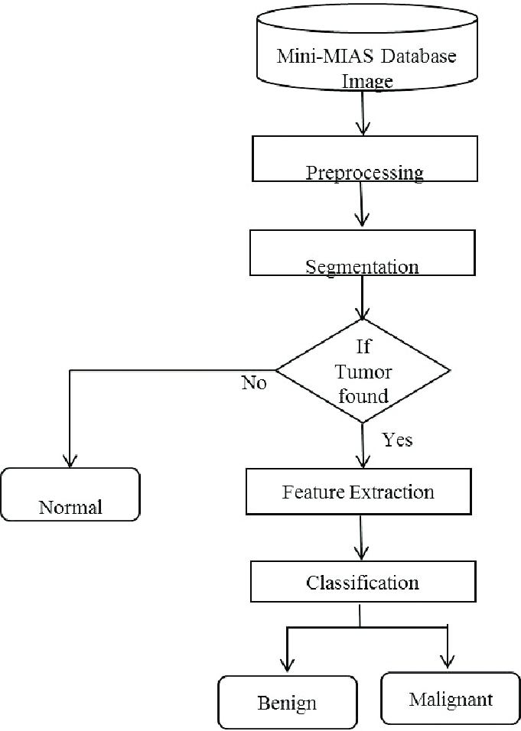

**7. RESULT**

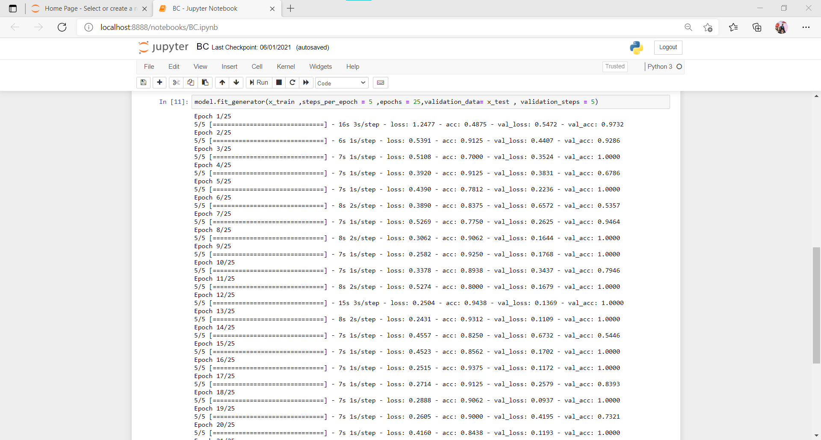

**8. ADVANTAGES & DISADVANTAGES**

**Advantages:**

* **You may receive a new treatment before it is widely available to the public.**
* **You can provide researchers with the information they need to continue developing new procedures and introducing new treatment methods.**
* **Your treatment costs may be decreased, since many of the tests and physician visits that are directly related to the clinical trial are paid for by the company or agency sponsoring the study.**

**Disadvantages**:

* If you participate in a randomized clinical trial, you may not receive the new treatment being studied.
* Many breast cancer clinical trials compare a new treatment along with current therapy versus the current therapy alone. Participants are randomly assigned to one or the other group.
* This will be explained to you before you decide to take part.As with other forms of therapy, the new treatment may not work for you, even if it helps others.Insurers do not always cover all of the costs associated with taking part in a clinical trial.
* Be sure to talk to your insurance provider before you decide to participate.There may be inconveniences, such as more frequent testing, more time at the doctor's office, and travel commitments.

**9. APPLICATIONS**

* The main application of this model is to predict the provided image is breast cancer or not. It is well trained so that it will predict the correct data
* After the model is built, we will be integrating it into a web application so that normal users can also use it. The users need to give the X-ray images to know the predictions.

**10. CONCLUSION**

* This machine-learning model can help breast cancer radiologist to assist them in predicting the malignant tumors at the early stage.
* Early stage detection not only leads to less treatment but also improves the chances of survival from breast cancer. Artificial Intelligence in Healthcare
* Computerized invasive ductal cancer identification is a difficult task and remains a downside in carcinoma diagnosis.
* However, correct and false IDC detection is a primary step while detecting and treating patients of BCa. Most of the existing
* works in histopathology neoplasm detection tackles this problem by combining different kinds of manual feature engineering
* options and machine learning algorithms. We presented a unique, in-depth learning framework for machine-driven detection
* of IDC regions in WSI of BCa histopathology.
* In this paper, eight different CNN architectures including VGG16, VGG19, Xception, Inception V3,
* each model was tested on the same data-set where obtained validation accuracy in Table 10 revealed that our proposed CNN
* model outperformed along with lower validation loss

**11.FUTURE SCOPE**

Build an app-based user interface in hospitals which allows doctors to easily determine the impact of tumor and suggest treatment accordingly Since performance and complexity of ConvNets depend on the input data representation we can try to predict the location as well as stage of the tumor from Volume based 3D images. By creating three dimensional (3D) anatomical models from individual patients, training, planning and computer guidance during surgery is improved. Using VolumeNet with LOPO (Leave-One-Patient-Out) scheme has proved to give a high training as well as validation accuracy(>95%).In LOPO test scheme, in each iteration, one patient is used for testing and remaining patients are used for training the ConvNets, this iterates for each patient. Although LOPO test scheme is computationally expensive, using this we can have more training data which is required for Convnets training. LOPO testing is robust and most applicable to our application, where we get test result for each individual patient. So, if classifier misclassifies a patient then we can further investigate it separately.

Improve testing accuracy and computation time by using classifier boosting techniques like using more number images with more data augmentation, fine-tuning hyper parameters, training for a longer time i.e. using more epochs, adding more appropriate layers etc.. Classifier boosting is done by building a model from the training data then creating a second model that attempts to correct the errors from the first model for faster prognosis. Such techniques can be used to raise the accuracy even higher and reach a level that will allow this tool to be a significant asset to any medical facility dealing with brain tumors. For more complex datasets, we can use U-Net architecture rather than CNN where the max pooling layers are just replaced by upsampling ones. Ultimately we would like to use very large and deep convolutional nets on video sequences where the temporal structure provides very helpful information that is missing or far less obvious in static images.

Unsupervised transfer learning may attract more and more attention in the future.

**12.BIBILOGRAPHY**

[1] Noone AM, Howlader N, Krapcho M, Miller D, Brest A, Yu M, Ruhl J, Tatalovich Z, Mariotto A, Lewis DR, Chen HS, Feuer EJ, and Cronin KA. Seer cancer statistics review, 1975-2015. Technical report, National Cancer Institute., Nov 2017.

[2] Itamar Arel, Derek Rose, and ThomasKarnowski. Deep machine learning - a new frontier in artificial intelligence research [research frontier]. Computational Intelligence Magazine, IEEE, 5:13 – 18, 12 2010. [3] Stephen B., Mittendorf Elizabeth Ann, Rugo Hope S., Solin Lawrence J., Weaver Donald L., Winchester David J., and Hortobagyi Gabriel N. Breast cancermajor changes in the American joint committee on cancer eighth edition cancer staging manual. CA Cancer Journal for Clinicians, 67(4):290–303, 72017.

[4] A. Basavanhally, S. Ganesan, M. Feldman, N.Shih,C. Mies, J. Tomaszewski, and A. Madabhushi. Multifield-of-viewframeworkfordistinguishingtumorgrade in ER+ breast cancer from entire histopathology slides. IEEE Transactions on Biomedical Engineering, 60(8):2089–2099, Aug2013.

[5] Y. Bengio, A. Courville, and P. Vincent. Representation learning: A review and new perspectives. IEEE Transactions on Pattern Analysis and Machine Intelligence, 35(8):1798–1828, Aug2013.

[6] Yoshua Bengio. Learning deep architectures for AI. Foundations and Trends in Machine Learning, 2(1):1– 127,2009.

[7] Fran¸coisChollet.Xception:DeepLearningwith Depthwise Separable Convolutions. In proceedings of IEEE Conference on Computer Vision and Pattern Recognition (CVPR), October2016.

[8] Bin Kong, Shanhui Sun, Xin Wang,Qi Song, Shaoting Zhang, Invasive Cancer Detection Utilizing Compressed Convolutional Neural Network and Transfer Learning, in proceedings of International Conference on Medical Image Computing and Computer-Assisted Intervention, 2018

[9] DanC.Cire¸san,AlessandroGiusti,LucaM.Gambardella,andJu¨rgenSchmidhuber.A fast learning algorithm for image segmentation with max-pooling convolutional networks. in proceedings of International Conference on Image Processing, pp. 411–418, 2013

**Appendix**

**CNN code:**

from tensorflow.keras.models import Sequential

from tensorflow.keras.layers import Dense

from tensorflow.keras.layers import Convolution2D

from tensorflow.keras.layers import MaxPooling2D

from tensorflow.keras.layers import Flatten

from keras.preprocessing.image import ImageDataGenerator

train_datagen = ImageDataGenerator(rescale = 1./255,shear_range = 0.2,zoom_range = 0.2,horizontal_flip = True)

test_datagen = ImageDataGenerator(rescale = 1./255)

x_train = train_datagen.flow_from_directory(r"E:\varunkumar\intenship\Breast Cancer\Breast Cancer\train",target_size = (128,128),batch_size = 32, class_mode ="binary")

x_test = test_datagen.flow_from_directory(r"E:\varunkumar\intenship\Breast Cancer\Breast Cancer\test",target_size = (128,128),batch_size = 32, class_mode ="binary")

Found 160 images belonging to 2 classes.

Found 40 images belonging to 2 classes.

model = Sequential()

model.add(Convolution2D(32,(3,3) ,input_shape = (128,128,3),activation = "relu"))

model.add(MaxPooling2D(2,2))

model.add(Flatten())

model.add(Dense(units = 512,activation = "relu",kernel_initializer = "random_uniform"))

model.fit_generator(x_train ,steps_per_epoch = 5 ,epochs = 25,validation_data= x_test , validation_steps = 5)

Epoch 1/25

5/5 [==============================] - 16s 3s/step - loss: 1.2477 - acc: 0.4875 - val_loss: 0.5472 - val_acc: 0.9732

Epoch 2/25

5/5 [==============================] - 6s 1s/step - loss: 0.5391 - acc: 0.9125 - val_loss: 0.4407 - val_acc: 0.9286

Epoch 3/25

5/5 [==============================] - 7s 1s/step - loss: 0.5108 - acc: 0.7000 - val_loss: 0.3524 - val_acc: 1.0000

Epoch 4/25

5/5 [==============================] - 7s 1s/step - loss: 0.3920 - acc: 0.9125 - val_loss: 0.3831 - val_acc: 0.6786

Epoch 5/25

5/5 [==============================] - 7s 1s/step - loss: 0.4390 - acc: 0.7812 - val_loss: 0.2236 - val_acc: 1.0000

Epoch 6/25

5/5 [==============================] - 8s 2s/step - loss: 0.3890 - acc: 0.8375 - val_loss: 0.6572 - val_acc: 0.5357

Epoch 7/25

5/5 [==============================] - 7s 1s/step - loss: 0.5269 - acc: 0.7750 - val_loss: 0.2625 - val_acc: 0.9464

Epoch 8/25

5/5 [==============================] - 8s 2s/step - loss: 0.3062 - acc: 0.9062 - val_loss: 0.1644 - val_acc: 1.0000

Epoch 9/25

5/5 [==============================] - 7s 1s/step - loss: 0.2582 - acc: 0.9250 - val_loss: 0.1768 - val_acc: 1.0000

Epoch 10/25

5/5 [==============================] - 7s 1s/step - loss: 0.3378 - acc: 0.8938 - val_loss: 0.3437 - val_acc: 0.7946

Epoch 11/25

5/5 [==============================] - 8s 2s/step - loss: 0.5274 - acc: 0.8000 - val_loss: 0.1679 - val_acc: 1.0000

Epoch 12/25

5/5 [==============================] - 15s 3s/step - loss: 0.2504 - acc: 0.9438 - val_loss: 0.1369 - val_acc: 1.0000

Epoch 13/25

5/5 [==============================] - 8s 2s/step - loss: 0.2431 - acc: 0.9312 - val_loss: 0.1109 - val_acc: 1.0000

Epoch 14/25

5/5 [==============================] - 7s 1s/step - loss: 0.4557 - acc: 0.8250 - val_loss: 0.6732 - val_acc: 0.5446

Epoch 15/25

5/5 [==============================] - 7s 1s/step - loss: 0.4523 - acc: 0.8562 - val_loss: 0.1702 - val_acc: 1.0000

Epoch 16/25

5/5 [==============================] - 7s 1s/step - loss: 0.2515 - acc: 0.9375 - val_loss: 0.1172 - val_acc: 1.0000

Epoch 17/25

5/5 [==============================] - 7s 1s/step - loss: 0.2714 - acc: 0.9125 - val_loss: 0.2579 - val_acc: 0.8393

Epoch 18/25

5/5 [==============================] - 7s 1s/step - loss: 0.2888 - acc: 0.9062 - val_loss: 0.0937 - val_acc: 1.0000

Epoch 19/25

5/5 [==============================] - 7s 1s/step - loss: 0.2605 - acc: 0.9000 - val_loss: 0.4195 - val_acc: 0.7321

Epoch 20/25

5/5 [==============================] - 7s 1s/step - loss: 0.4160 - acc: 0.8438 - val_loss: 0.1193 - val_acc: 1.0000

Epoch 21/25

5/5 [==============================] - 7s 1s/step - loss: 0.2233 - acc: 0.9438 - val_loss: 0.0918 - val_acc: 1.0000

Epoch 22/25

5/5 [==============================] - 7s 1s/step - loss: 0.2122 - acc: 0.9375 - val_loss: 0.0755 - val_acc: 1.0000

Epoch 23/25

5/5 [==============================] - 7s 1s/step - loss: 0.2131 - acc: 0.9438 - val_loss: 0.0624 - val_acc: 1.0000

Epoch 24/25

5/5 [==============================] - 7s 1s/step - loss: 0.2121 - acc: 0.9375 - val_loss: 0.0834 - val_acc: 1.0000

Epoch 25/25

5/5 [==============================] - 7s 1s/step - loss: 0.2221 - acc: 0.9438 - val_loss: 0.1027 - val_acc: 1.0000

Out[11]:

<tensorflow.python.keras.callbacks.History at 0x1a0161dd630>

model.save("BC.h5")

**Prediction Code**

from tensorflow.keras.models import load_model

from tensorflow.keras.preprocessing import image

import cv2

import numpy as np

model = load_model(r"E:\varunkumar\internship\BC.h5")

img = image.load_img("malignant2.png",target_size = (128,128))

type(img)

PIL.Image.Image

x = image.img_to_array(img)

type(x)

numpy.ndarray

x.shape

(128, 128, 3)

x = np.expand_dims(x,axis=0)

x.shape

(1, 128, 128, 3)

pred = model.predict(x)

pred

array([[1.]], dtype=float32)